EXPT NO:5 | DASHBOARD DESIGNING
DATE: 24.01.2026 | DASHBOARD DESIGNING

PRE-LAB QUESTIONS
- How do dashboards support strategic decision-making?
Dashboards present key insights, trends, and patterns from large datasets in a visual and summarized form. This allows decision-makers to quickly understand the current situation, identify opportunities or problems, and compare performance against goals. By transforming raw data into meaningful charts and KPIs, dashboards help organizations make faster, evidence-based, and informed strategic decisions.

- What role do dashboards play in AI monitoring systems?
In AI systems, dashboards are used to monitor model performance, accuracy, error rates, data drift, and predictions in real time. They help analysts detect anomalies, bias, or degradation in models early. Dashboards also visualize training progress and output patterns, enabling continuous evaluation and improvement of AI models.

- Why is interactivity essential in modern dashboards?
Interactivity allows users to filter, drill down, zoom, and explore data from different perspectives. This supports deeper exploratory analysis instead of static viewing. Users can focus on specific variables, time periods, or categories, making dashboards more flexible, personalized, and useful for discovering hidden insights.

- What cognitive overload issues exist in dashboards?
Cognitive overload occurs when dashboards display too many charts, colors, or metrics at once. This can confuse users, slow understanding, and lead to poor decisions. Poor layout, unnecessary decorations, and excessive data labels increase mental effort. Simple design, clear hierarchy, and focusing on essential metrics reduce cognitive overload.

- How are KPIs derived from raw data?
KPIs are created by cleaning, transforming, and aggregating raw data. Relevant metrics are selected based on business or analysis goals. Statistical operations such as averages, counts, ratios, and percentages are applied to produce meaningful indicators. These indicators are then validated and tracked as KPIs.

OBJECTIVE: To design an interactive analytical dashboard for monitoring key metrics.
SCENARIO: An AI-based smart campus system requires a dashboard to monitor attendance, academic performance, and resource utilization in real time.
IN-LAB TASKS (Using PowerBI)
• Design KPI cards for attendance and performance
• Implement filters by department and semester
• Link multiple views for drill-down analysis

PROCEDURE:

Step 1: Open Power BI Desktop and create a new blank report.

Step 2: Click Home → Get Data → Text/CSV and select the file 5.student_performance.csv.

Step 3: Click Transform Data to open the Power Query Editor.

Step 4: Review the dataset columns such as Student_ID, Department, Semester, Subject, Attendance_Percentage, Internal_Test1, Internal_Test2, Assignment_Marks, and Final_Grade.
Step 5: Go to Add Column → Custom Column to create a calculated column.

Step 6: Enter the column name as Total_Score.

Step 7: Type the formula:
[Internal_Test1] + [Internal_Test2] + [Assignment_Marks]

Step 8: Click OK and then select Close & Apply to load the data.

Step 9: Insert a Text Box and enter the title Smart Campus Monitoring Dashboard.

Step 10: Insert a Card Visual and drag Attendance_Percentage into the field, then change aggregation to Average.

Step 11: Insert another Card Visual and drag Total_Score into the field, then change aggregation to Average.

Step 12: Add a Slicer Visual and place the Department field for filtering.

Step 13: Add another Slicer Visual and place the Semester field for filtering.

Step 14: Insert a Clustered Column Chart for performance visualization.

Step 15: Drag Total_Score to Values and set it to Average.

Step 16: Drag Department, Semester, and Subject into the X-Axis to create a hierarchy.

Step 17: Enable Drill-Down and test navigation between department, semester, and subject levels.

Step 18: Insert a Pie Chart for grade analysis.

Step 19: Drag Final_Grade to Legend and Student_ID to Values and set it to Count.

Step 20: Arrange all visuals neatly, test interactivity, and save the report.

OUTPUT:
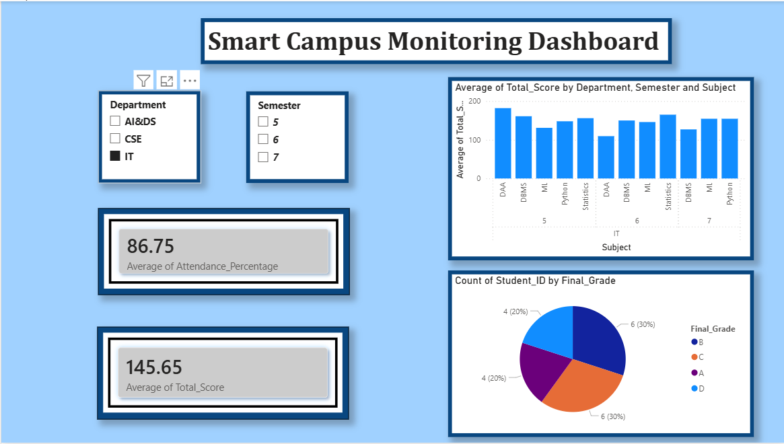

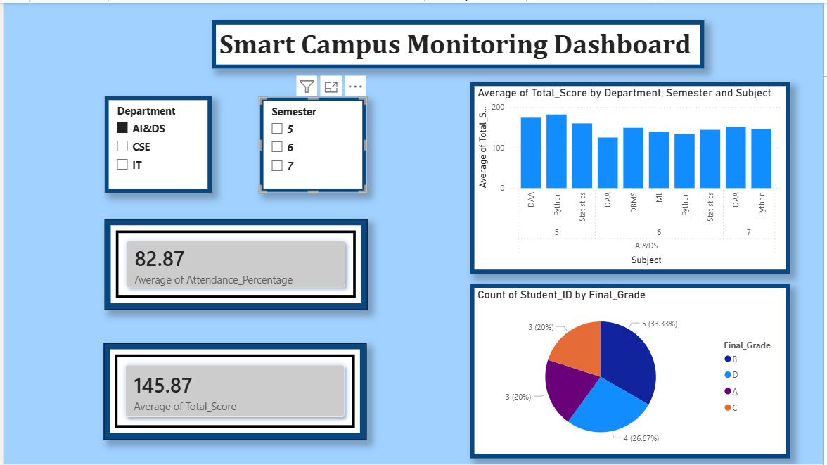

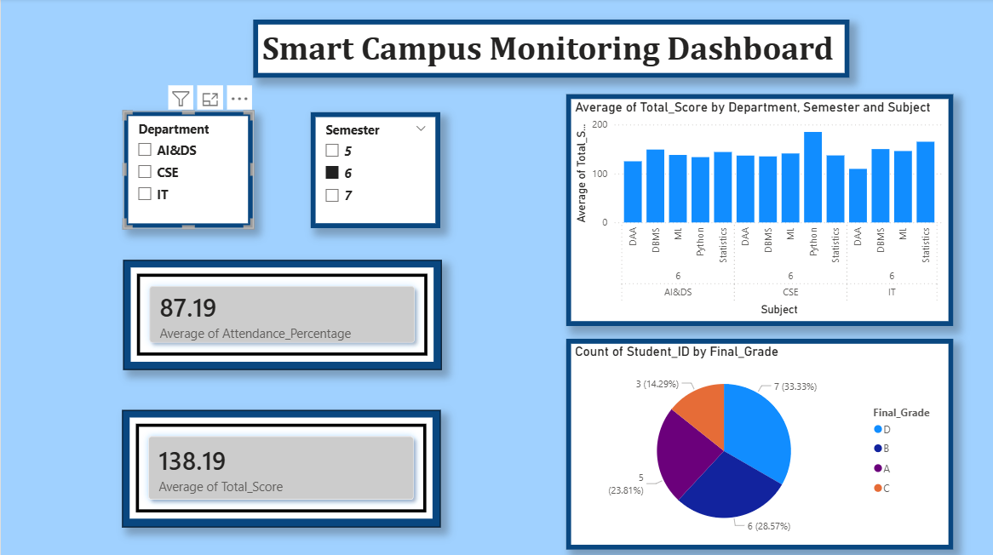

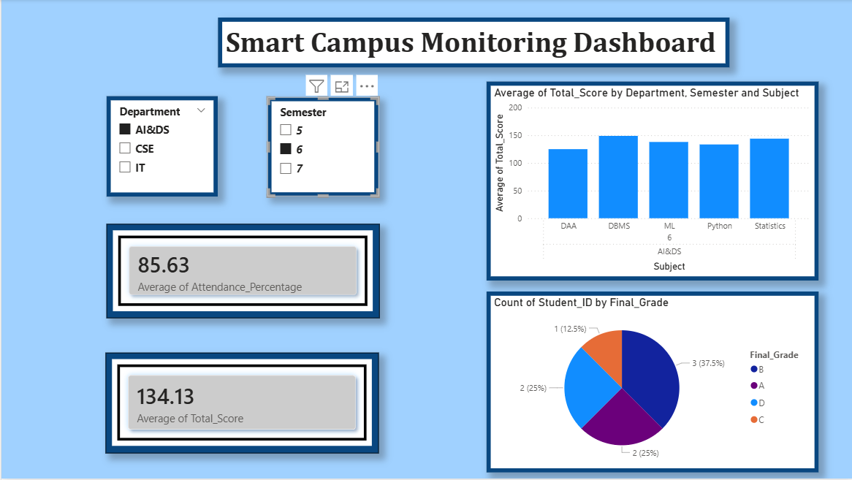

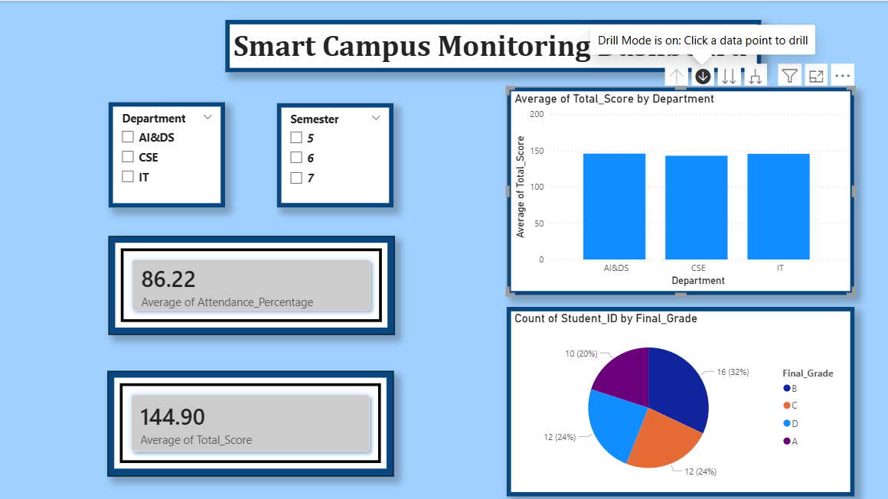

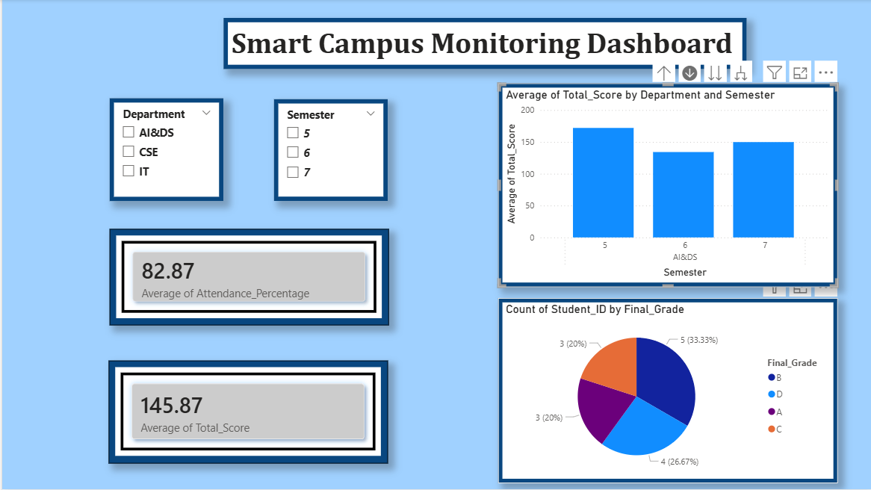

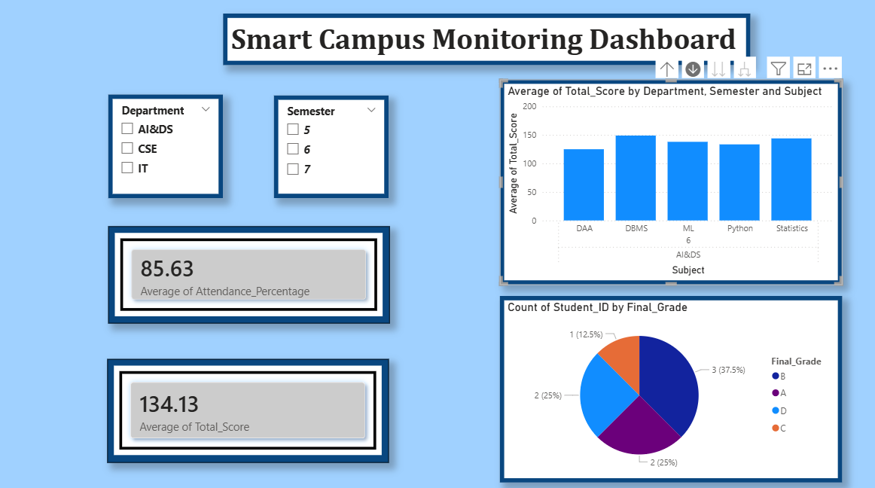

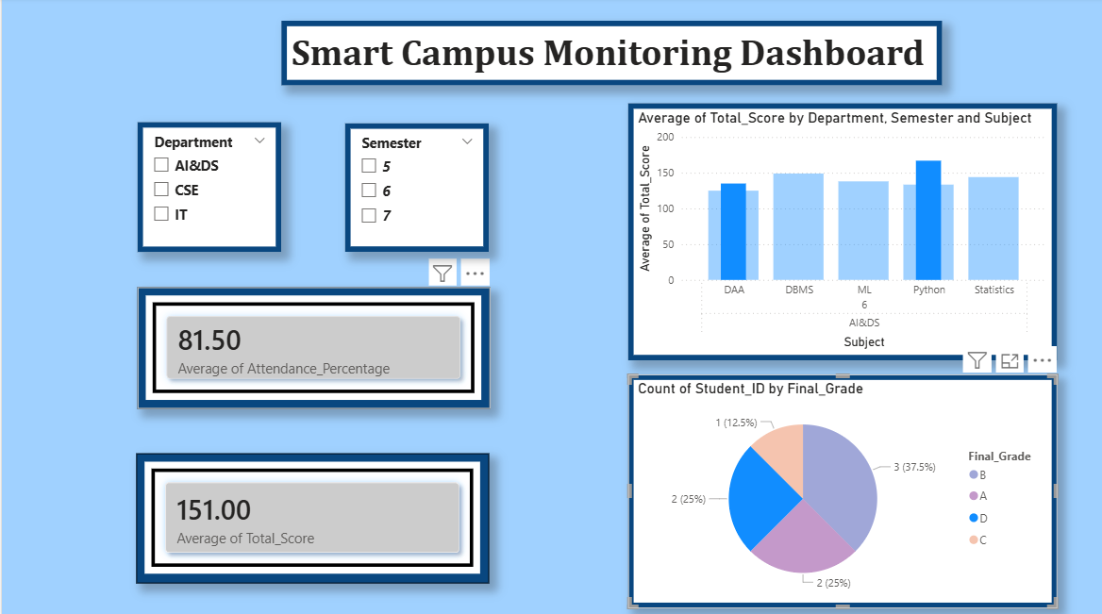

POST-LAB QUESTIONS
- How does interactivity improve analytical depth?
Interactivity allows users to filter data by department and semester, drill into specific subjects, and compare performance across categories. This enables deeper exploration of patterns, trends, and anomalies rather than viewing only overall summaries. As a result, users can perform detailed exploratory analysis and gain more meaningful insights.

- Which KPIs are critical for academic monitoring?
Key KPIs include average attendance percentage, average total score, subject-wise performance, and grade distribution. These indicators help monitor student engagement, academic achievement, and overall performance quality across departments and semesters.

- What design principles prevent information overload?
Using a clean layout, limited color palette, clear labels, and well-organized sections prevents clutter. Displaying only essential KPIs and using appropriate chart types (bar and pie charts) improves readability. Proper spacing and consistent formatting help users focus on important information.

- How can dashboards be integrated with AI alerts?
Dashboards can connect with AI models that continuously analyze data and trigger alerts when unusual patterns occur, such as low attendance, sudden score drops, or high failure rates. These alerts can be displayed as notifications or highlights on the dashboard for timely intervention.

- How do dashboards enhance transparency in institutions?
Dashboards present performance data in a clear and accessible way to administrators, faculty, and stakeholders. This visibility promotes accountability, supports data-driven discussions, and ensures that academic decisions are based on factual evidence rather than assumptions.

LEARNING OUTCOME: Students understand dashboard design for AI-driven environments.
ASSESSMENT
Description | Max Marks | Marks Awarded
Pre Lab Exercise | 5
In Lab Exercise | 10
Post Lab Exercise | 5
Viva | 10
Total | 30
Faculty Signature

